***Numeracy, mathematics and Indigenous learners***

*This paper will help you in considering the important or significant things that have happened in your* Make it count *Cluster and which will form part of your evidence base and your contribution to the* Make it count *Resource.*

**Significant Episodes**

A Significant Episode is an event, or a small series of linked events, that has impacted on you professionally and has helped develop or change the way you teach and think about teaching. It may be within the classroom, within your *Make it count* Cluster, or peer-to-peer. Generally, your Cluster Findings have derived from these Significant Episodes. They are a great form of data.

What does a significant episode look like?

There is a simple structure:

1. There is an issue/problem/question?
2. Something significant happens
3. Reflection – why did I do this? What do I do next? What is the message in this?

A Significant Episode is a short-term thing and sits somewhere between a snapshot and a case study. In other words, it isn’t too big. When thinking about a Significant Episode consider WHY it was significant eg it might have been the first time an Aboriginal student discussed a particular maths concept with you. A Significant Episode illustrates a particular point you’re trying to make, and is an example of something, that is, one of your Cluster Finding in action.

Educators talk about things that happen in the classroom all the time - over a cup of coffee or during lunchtime. This teacher-talk is often about something significant, such as a realisation, an epiphany or something worth celebrating.

Look at your Cluster Findings and recall why you say this ie what happened that was significant to make you say that this is important for your Cluster. (Remember that Cluster Findings are directly linked to your Cluster focus or question - see #1 above.)

These Significant Episodes can be important data for you to use in your cycles of action research and inform the development of responsive mathematics pedagogy for Aboriginal and Torres Strait Islander learners.

An example of a Significant Episode from the Noarlunga Cluster follows. Here Rosie describes a series of significant events that occurred for her and one of her Aboriginal students (and this student’s mother). These events helped Rosie in developing the explicit, scaffolded pedagogy they now use in the Cluster.

Read through Rosie’s Significant Episode and identify the important parts. Consider why they are significant and discuss with your colleagues. This will help you in considering your own Significant Episodes and how you can articulate them.

From Professor Alan Bishop

*“Don’t forget about the power of the ‘significant episode’. They are great devices for communication so think about putting them up front...Research is not just about data collated from tests. Case studies are valued in the research community. I see people putting a lot of emphasis on NAPLAN results but overlooking those significant episodes that can really show what is happening.”*

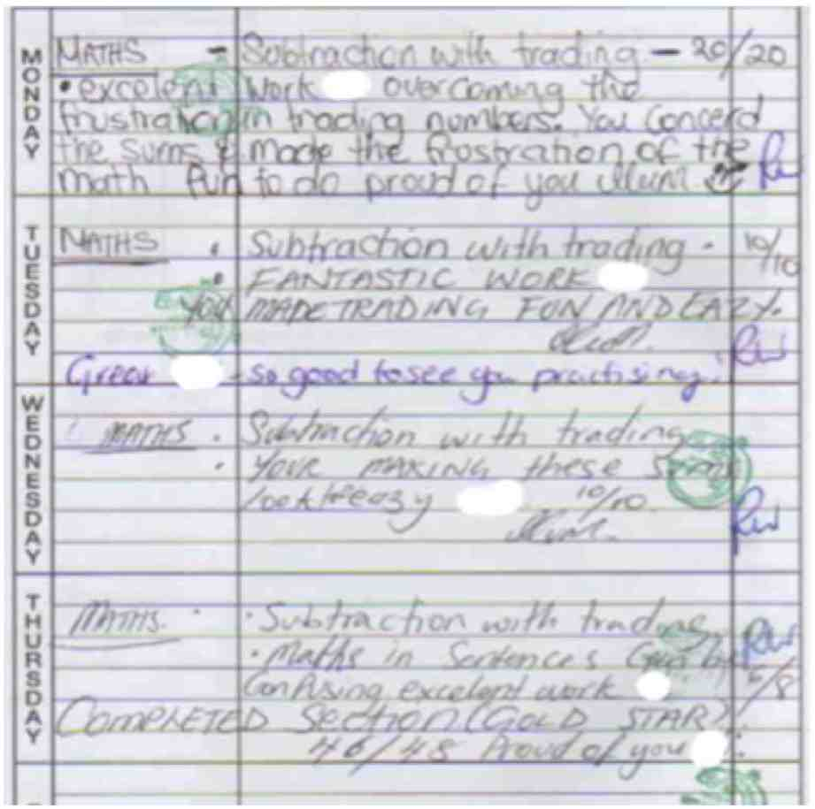**Significant episode**

**Cluster finding**

Strong mathematics skills in students build confidence and enthusiasm for mathematics and this encourages risk taking which is an integral part of mathematics learning.

*From: Cluster Findings/Professional Practice/Being Effective/Create and maintain supportive and safe mathematics learning environments*

**What ANDREW’S DIARY tells me:**

This was not set as homework. He just went home and did it himself every night for the week. (I always say to the children that they can practise Maths at home. Until this, hardly any children ever did extra Maths at home.)

Andrew’s mum commented on his enthusiasm in his diary.

“He conquered his frustration of the Maths”, wrote Mum.

By Thursday Andrew has started solving written question problems and was able to transfer these into symbols and calculate successfully.

“Proud of you Andrew”, says Mum.

Surprisingly, at the next student-parent-teacher interview both parents attended and commented very favorably on Andrew’s attitude, success and enjoyment in Maths.

(After Andrew shared this homework, many children in the class started bringing in pages and pages of self-initiated practice of the current concept we were tackling.)

**What happened** *by Rosie Wilkinson, Noarlunga Cluster*

At the beginning of the year and throughout most of term one Andrew, a Year 4 Aboriginal boy, presented as a quiet under achiever who was lacking in confidence particularly in the area of mathematics. Towards the middle of term one I changed my pedagogy in this subject area and brought it into line with how I taught Accelerated Literacy. For our maths lessons my teaching Mentor and I planned a series of scaffolded, sequential lessons in the area of “place value”…We noticed immediate results in both enthusiasm and confidence building within the classes. The scaffolding, small incremental steps and questioning that follows the Accelerated Literacy pedagogy allowed the students to become confident in asking and answering questions and gave us a better indication of their true understanding. It was easier to assess gaps in learning and address these with the students. Andrew, in particular, began to shine in the lessons. He gradually became more confident to offer answers. He now asks questions when he doesn’t understand. He shows that he enjoys mathematics and is eager to share his knowledge with others. He goes home and shares what he knows with his parents who have been delighted with this transformation. They have written notes in his diary that confirm this:

**Cluster question**

Can we improve mathematics/numeracy for Aboriginal Primary Years students through using the highly successful scaffolded pedagogy of Accelerated Literacy and developing a sequence of lessons based on “Big Ideas in Number”?